Report on the 2019-2020 Season at Deir el-Ballas

The Ancient Egyptian Heritage and Archaeology Fund

Our goals for the Deir el-Ballas 2019-2020 season which ran from December 1st, 2019 to January 25th 2020, was to continue the conservation work at the ‘South Palace’ along with the houses of the workers to the West of the North Palace and the North Palace itself. The houses in particular were threatened by the expansion of the modern cemetery which had destroyed a number entirely. We began by cleaning House D, which we had covered at the end of the season last year to protect, in preparation of reconstructing the walls with modern unbaked mud brick made to match the original. Nick Brown began to clean House E, which Peter Lacovara had originally cleared in the 1980’s, and had been planned by Reisner in his 1900-1901 season.

Tony Crosby reconstructed the walls of the structure with modern unbaked mud brick made to match the original and set in a pattern that mimics the bonding pattern used in the original construction. In cleaning we found more confirmation that this house was used, at least in part, as a bakery, finding a number of quartzite grindstones and grinders in association with the silos in the large central court of the house, as well as more pottery bread trays.
To the southwest of House E we began exploring a structure that had been cut by a modern roadway. On the western edge of the remaining architecture, designated ‘House F.’ Although this house appears to have been originally excavated by Reisner and noted in a 1980 survey, we still found a thick deposit of mud seals and mud ‘eggs’ which appear to have been made as blanks for seals. Piet Collet undertook the recording of this interesting building which may have served some sort of administrative function for the North Palace. He also continued to survey the site.
Vicky Jensen planned the area to the west of House E as well as worked
processing the artifacts found this season along with the help of two trainees from the inspectorate office in Qena, Engy Mamdouh Kamal and Martha Ebrahim Todary. Bettina Bader also joined the expedition to study the ceramic material particularly from Houses E and F. We also began the reconstruction of the southern part of the main enclosure wall of the North Palace in order to protect it and also began reconstruction of the Southwest corner of the casemate core of the North Palace in danger from a neighboring roadway. In addition, according to the Inspectorate office in Qena we had the area around the North Palace cleared of modern trash dumped around it and made a survey to begin construction of a brick and concrete barrier wall to protect the antiquities area. The exposed brickwork not reconstructed this season will be covered by sand to protect it and removed the next season to begin restoration work.

We would like to thank Dr. Khaled El-Enany, Minister of Antiquities and Tourism, Dr. Mostafa Waziri, Secretary-General of the Supreme Council of Antiquities, Dr. Nashwa Gaber, Supervisor of the Permanent Committee of the Antiquities Department, Mostafa Hassan, General Director for the Egyptian Committee, Iyman Hindy, General Director of Qena Antiquities, Maryanne Danielle, Director of Qena Area, Abdullah Mohammed Abdullah, Director of West Bank Antiquities of Qena, Amr Gad el Rab, Head of Foreign Missions and Excavations of Qena, Ahmed Sawarat Mohar and Hashem Hassan Abdel Rady Conservators of the Qena Area, and our Inspectors, Georgette Wagi Hanna and Marwa Abdel Hamed Denderawi. We also want to thank our antiquities trainee Mohammed Shahat Shamrouk along with Dr. Salima Ikram, Mr. Magdy Aly and the American University in Cairo for their help and support and to Dr. Pearce Paul Creasman and the University of Arizona Egyptian Expedition for their kind and generous hospitality.

- Cleaning the ‘South Palace’ before conservation 2018.
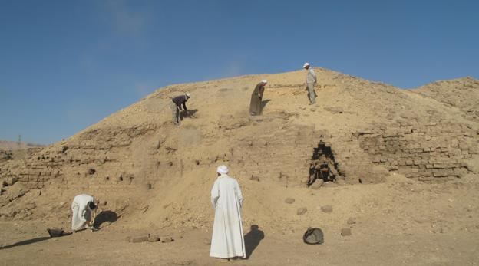

- The ‘South Palace’ undergoing conservation.

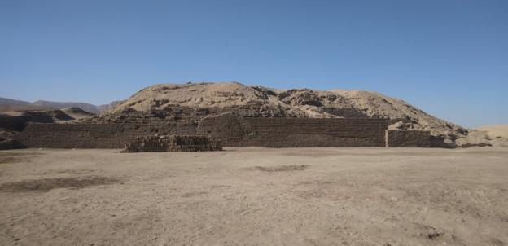

- House D beside the North Palace’ before conservation.

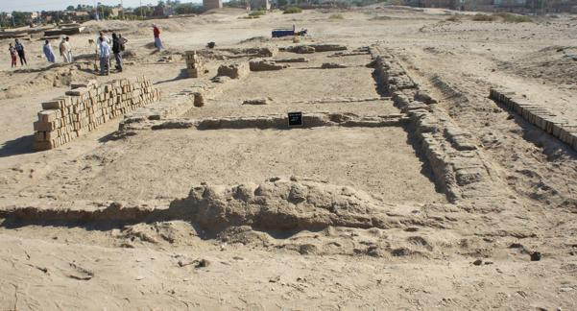

- House D beside the North Palace’ during conservation.

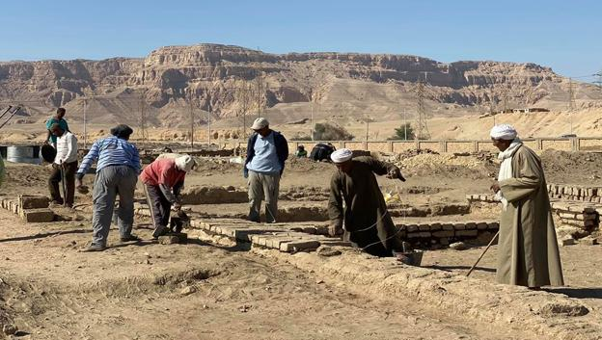

- House E being cleaned by Nicholas Brown.
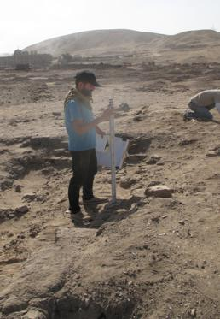

- Tony Crosby Supervising brick conservation.
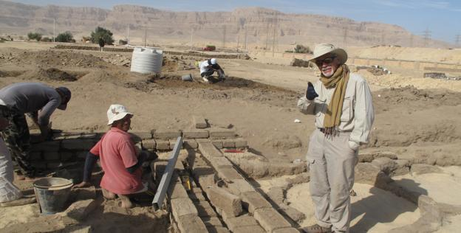

- Piet Collet surveying the site.
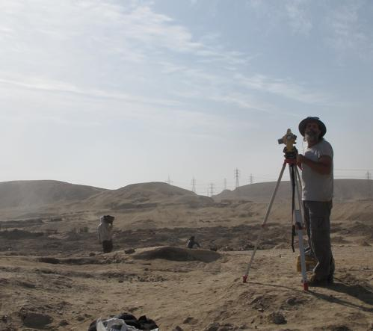

- House F with mud ‘eggs’ and wine jar.

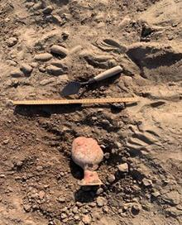

- Cleaning the southern enclosure wall.

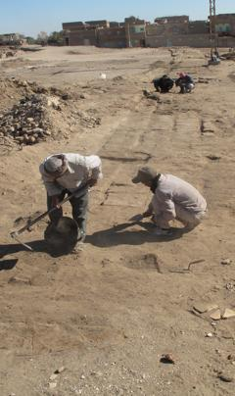

- House D Restoration Complete.

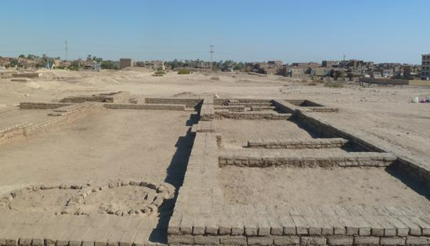

- Map of the site.

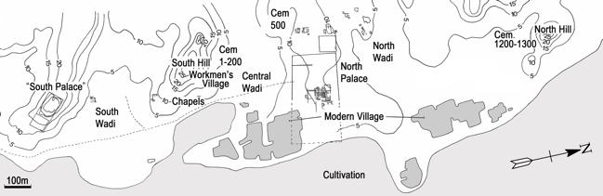

- Reconstruction of main enclosure wall in the North Palace

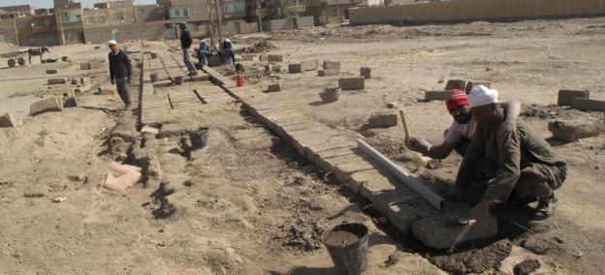

- Conserving some of the casemate foundations in the North Palace

